The Missing Context Dataset Analysis
Prepared by: Rofiat Muhammad.
Introduction
This report studies a daily dataset from 2018 to 2024 that shows clear rhythms, sudden breaks, and shifting relationships among five variables. The goal is to understand what kind of system this might represent, why its behavior changes over time, and what the major anomalies reveal. The patterns suggest seasons, pressure, adaptation, and recovery, but the true context is unknown.
Data Ontology
The dataset comprises daily observations from 2018 to 2024 of five unnamed numerical variables: Var1 to Var5 with date being known. Initial statistical exploration reveals:
- Var1: A high-magnitude activity metrics of 7 to 156. Before 2020, it shows a strong seasonal peak cycle of each year. This looks like physical movement or an economic throughput.
- Var2: is centered near zero from -0.7 to 0.7. This looks like a confidence level or sentiment.
- Var3: A low-magnitude counterpart to Var1 of 0 to 22. It mirrors Var1 closely with the cycle. It looks like local transactions or micro interactions.
- Var4: Sparse binary spikes of 0 or 1. It is uncorrelated with other variables. which might be a trigger or an event flag such as holidays, policy changes, or system interventions.
- Var5: is a medium magnitude of 2 to 60 that behaves inversely to Var1 and Var3. This might be a substitution signal or a digital proxy like remote work logins, home internet usage, or digital engagements.
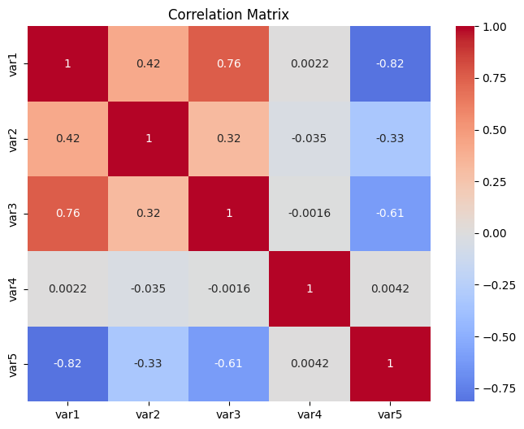
Fig 1; the heatmap plot showing the correlations among the variable.

The correlation analysis confirms this structure:
- Var1 and Var3: r = +0.76 suggesting tightly coupled. These two variables are linked conventionally.
- Var1 and Var5: r = -0.82 suggesting strong substitution effect implying causality.
- Var2 moderately correlates with Var1: r = +0.42 suggesting sentiment influences behavior. This also implies causality
- Var4 is uncorrelated, suggesting an external trigger. Which confirms conventional
The data exhibits:
- Seasonal cycles of summer peak before 2020.
- Collapse in March 2020.
- Asymmetric recovery of a new baseline, lower activity, elevated substitutional signal.
- Persistent psychological scarring when var2 never returns to the seasonal cycles before 2020.
It is most likely that this dataset reflects a human behavioral system, something like a city economy or a social environment reacting to a major shock.
Hypothesis Taxonomy
I identified three structural anomalies using rolling z-score analysis and the multivariate Anomaly Detection. The following are the three anomalies detected:
1st Anomaly happened around August 2019.
Observation: Var3 dropped from 16.2 to 10 with Var1 from 136 to 82 while other variables are stable.
Hypotheses:
- Economic: Local supply chain shock such as port strike, small business regulation.
- Behavioral: Social media panic affecting niche activity.
- Technical: Isolated sensor error or data pipeline glitch.
Plausibility Ranking:
- Highest: Economic is ranked highest because Var3 is low magnitude like a local economy while Var 1 is unaffected and suggests an isolated shock.
- Medium: Behavioral is ranked second because plausible but harder to sustain for one day.
- Lowest: Technical is ranked low because the possibility is low.
2nd Anomaly happened around March 2020.
Observation: Var3 dropped from 15 to 5 and Var1 dropped from 100 to 20 while Var5 surges higher from 30 to 45.
Hypotheses:
- Economic: Global lockdowns due to pandemic which reduced physical activity and caused increased in digital surges.
- Behavioral: Mass panic triggers voluntary withdrawal from public spaces.
- Environmental: natural disasters like earthquakes and floods that force evacuation.
Plausibility Ranking:
- Highest: Economic is the first because it aligns with global timeline, explains substitution increase in var 5, matches asymmetric recovery.
- Medium: Behavioral consistent with data, but less precise; doesn’t explain policy-like timing.
- Lowest: Environmental ranked third since there is no evidence of localized recovery because disasters do not cause sustained digital shift.
3rd Anomaly happened around May 2021.
Observation: Var3 surges from 5 to 15.9, Var 1 rise along with Var3 from 14 to 137. Var 5 on the other end reduced drastically from 54 to 25.
Hypotheses:
- Economic: Vaccination rollout and stimulus spending enable reopening.
- Behavioral: Social reintegration after prolonged isolation.
- Technical: Data normalization reset or reporting change.
Plausibility Ranking:
- Highest: Economic is high because the recovery is gradual, not instant which rules out technical glitch.
- Medium: Behavioral ranking is supported by emotional rebound but less predictive of scale.
- Lowest: Technical ranked lowest because it is contradicted by smooth pre and post trends.
First Narrative
Assuming the dataset is from a global city, recording the activities like the following.
Var1: Daily foot traffic in commercial districts.
Var2: Investors’ confidence level.
Var3: Small business and startup sales performance.
Var4: Trade restriction.
Var5: Home internet usage or remote work logins.
The system has always moved in seasonal cycle until the first anomaly that happened in August 2019 which break the consistent pattern, it might be a regional economic shock that happened in response to policy shifts or the trade war tension that happened between US and China. Thus, affecting small business and startup activities showing why Var3 drops and then Var2 begins to turn negative indicating the reduction in the confidence level of Investors.
Then, in March 2020, another anomaly changed everything at once. A sudden global health crisis caused lockdown in the world. It looks like an overall stop in the city, which makes the streets empty; Var1 crashes indicating the drop in the daily foot traffic, Var3 crashes also, as all businesses were forced to close. The reduction in physical activity caused an increase in home internet usage or remote work logins indicating Var5 high surges.
By the end of May 2021, the city started to recover a bit after reopening of business and activities started becoming normal but cautious. Foot traffic returns slowly, and it starts to recover which extend into 2023. Remote work and internet usage dropped as a return of business, but it wasn’t lower than the way it was before the pandemic rather it kept fluctuating indicating the continuous remote work and internet usage which justify why Var5 stays elevated indicating that the system survives.
The Counter Narrative
What if the data assumed is not recorded from human or natural activities rather it is a telemetry from a multi-agent simulation like a prototype for a smart city or a digital twin environment. The dataset interpretation below is assumed to be from remote monitoring.
Var1: simulated vehicle traffic.
Var2: system health or integrity score.
Var3: Non-player character NPC interactions such as simulated small business activity.
Var4: scheduled maintenance triggers.
Var5: physically controlled vehicle traffic.
For this interpretation, August 2019 anomaly is not from regional economic shock but rather the perceived negative effect in Var2 is a simulation bug or rule update that reduced NPC interactions which indicate the drop in Var3.
Then in March 2020, developers intentionally activated a global crisis module from a stress-test scenario modeling a pandemic. This module forced a halt on simulated physical movement indicating the crash of Var1 and the non-player character showing why Var3 collapses, while redirecting activity to physical human-controlled vehicle making Var5 surge high. The synchronization is not coincidence, rather it is a scripted behavior.
In May 2021 the anomaly recovery was not organic, it was a rollback or fix that re-enabled movement and NPC interactions. Yet, the system health score Var2 never fully recovered because of error log or residual anomalies remained in the simulation state.
Reflection on Epistemic Uncertainty
Since we are analyzing data without context, uncertainty is built into every interpretation. Several assumptions hold the narrative together:
- I assumed it is daily data from different systems, but it could be the same system.
- I suggested human behavior due to sentiment influenced patterns, but it could be from natural factors and AI systems can as well mimic emotion.
- I referenced the 2020 pandemic it could be engineered logic or a natural disaster.
My narrative will be false if:
- Var5 is revealed to be temperature in Celsius indicating natural factor system
- Var4 is proven to be random noise that was not recorded from event.
- External data shows no global crisis in 2020 but a video game simulation.
Quantifying my Epistemic Uncertainty
The chart below visualizes the epistemic statistical uncertainty computing a 60-day rolling mean and standard deviation.
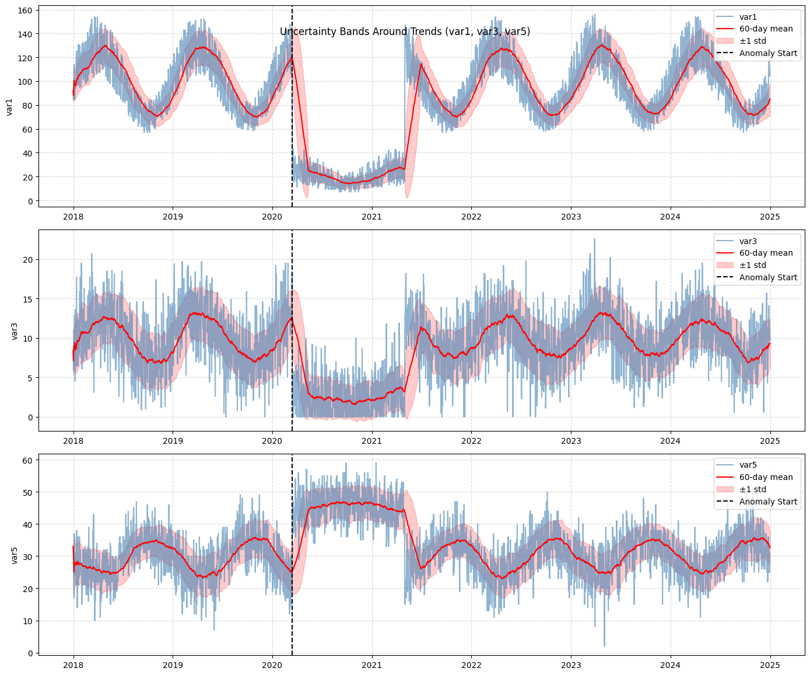
Fig 2: charts to quantify Uncertainty.
Key Insight:
Var1 drops from 100 to 20. Which is more than 3 standard deviations below its rolling mean.
Var3 collapses from 15 to 5. It is also 3 std below trend.
Var5 surges from 30 to 45 and it is 2 std above trend.
So, quantifying my uncertainty.
- Statistically: in March 2020, Var1 and Var3 drop exceed the 3std implying that has 0.3% probability of happening under normal conditions.
- Interpretively: I estimate 70% confidence that this is a human behavioral system, 20% that it is a simulation and 10% that it is something else.
- Even if I am sure that my hypotheses are anomaly the cause is still unknown.
Conclusion
The analysis shows a system that moves steadily until three disruptions reshape its direction. The strongest explanation points to economic or behavioral shocks, especially around 2020, though other interpretations remain possible. The system adapts, settles, and forms a new pattern that never fully returns to its earlier state.

